***Завдання до теми***

***Clothes***

BD00141_

**Level 1**

**1. Find these people in the picture. What are they doing?**

* a boy in a checked shirt and trainers
* a girl in a flowery dress
* a girl in dark-blue jeans
* a man wearing dark-brown boots
* a man wearing a light-blue uniform
* a woman wearing a polka-dotted scarf
* a girl in a striped skirt

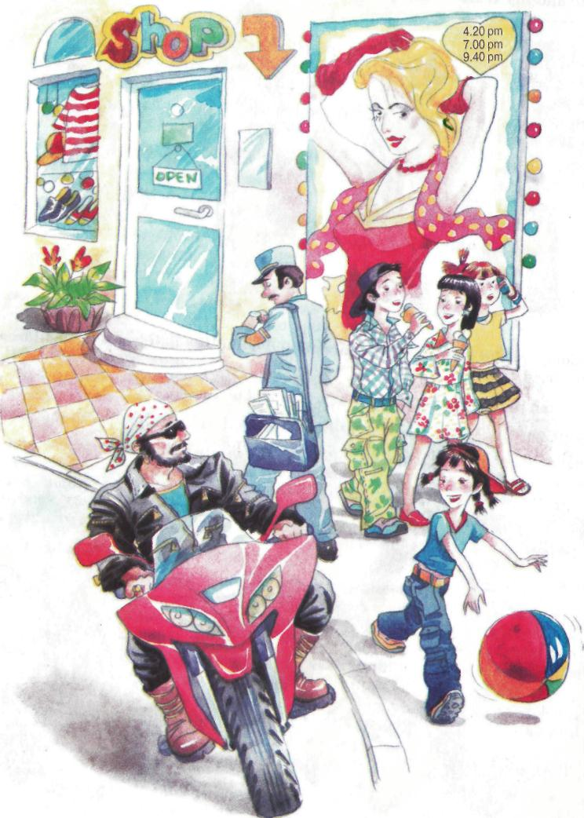

**2. Underline the odd word in each line.**

milk, cream, cheese, flower

biscuits, cakes, meat, chocolates

to buy, to write, to sell, to pay

market, supermarket, bakery, post office

**Level 2**

**1. Read the description and name the answers: *trousers, coat, old, door, eyes, cap, fair, socks, shoes, chair***

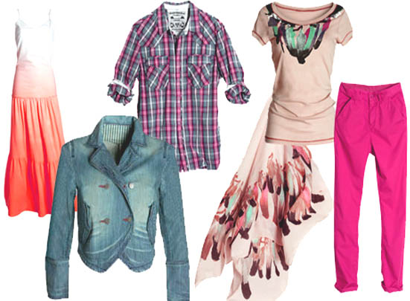

|  |
| --- |
| 1. Not new. - \_\_\_\_\_\_ |
| 1. We have them on our feet. - \_\_\_\_\_ |
| 1. Your hair is not dark, it is \_\_\_\_\_. |
| 1. We see with our \_\_\_\_\_. |
| 1. You put it on. - \_\_\_\_\_ |
| 1. You can see it in a room. You may open or shut it. - \_\_\_\_ |
| 1. You can sit on it. - \_\_\_\_\_ |
| 1. Boys and girls have them on their legs. - \_\_\_\_\_\_\_ |
| 1. You have it on your head. - \_\_\_\_\_\_ |
| 1. It is not a skirt. Boys and girls put them on. - \_\_\_\_\_\_\_ |

**2. Read and choose the right picture.**

a. We have to wear a school uniform at our school. I wear a green jacket, a grey jumper? Grey trousers and black shoes. We have to wear a white shirt, but worst of all we have to wear a tie – a grey and green tie.

b. Our school colours are blue and yellow. In the winter I wear a blue jacket, a blue skirt, a yellow blouse and a blue jumper. We have to wear a blue and yellow tie, too, and a blue hat. It’s summer now, so we can wear a yellow dress or a blue dress (mine’s blue). We don’t have to wear a tie, but we still have to wear the hat. We can wear tights or white socks and black shoes or sandals.

c. At the weekends I wear jeans and a T-shirt. This is my favourite T-shirt. It’s yellow. I also wear an anorak and brown boots. Do you like my red braces? Good, aren’t they?

d. At the weekend I like to wear lots of different things: sometimes I wear jeans or a skirt or a dress. I’m wearing shorts at the moment, because the weather’s warm. they’re dark green. My T-shirt is green and white and my trainers are yellow.

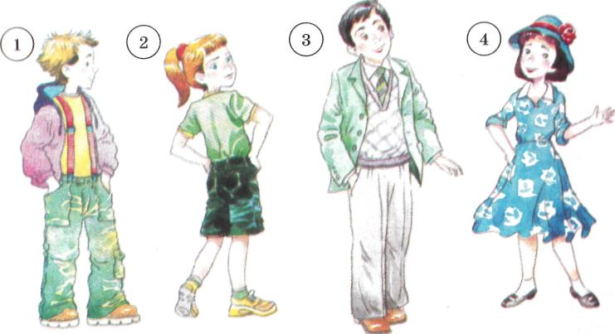

**Level 3**

**Make up questions starting them with the interrogative words in brackets.**

1. Mother usually buys all necessary goods. (Who?)
2. The family buys vegetables at the market. (Where?)
3. We can buy sweets and chocolates at the confectioner store. (What?)
4. We have got a bakery near our house. (Who?)
5. It is convenient to do shopping at the supermarket in any weather. (When?)

**Level 4**

**1. On a piece of paper, write what you are wearing at the moment. Give the paper to the teacher to read out. Can other students identify you?**

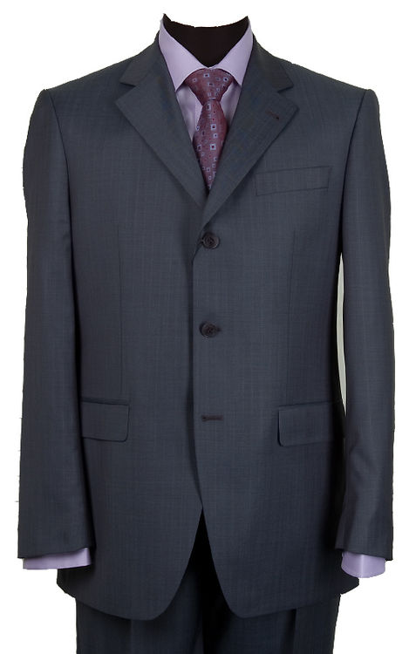

**2. Find and correct mistakes in each sentence.**

Each large city have got a plenty of department stores.

We can sees clothes in the shop windows.

Customers buys footwear in the shoe department.

Men has got a good choice of suits.

All woman like visiting their clothing department.

It are typical for most women to get crazy about clothes.